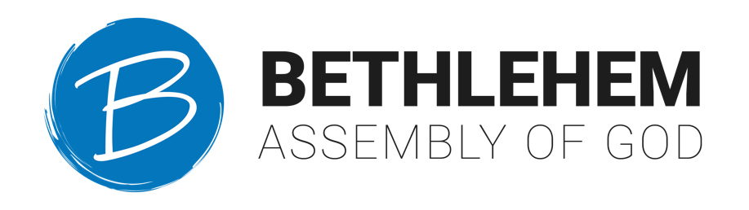

Job Title: | Front Desk Assistant | Job Category: | Non-Exempt
Department: | Administration | Travel Required: | None
Location: | Main Campus | Position Type: | Full Time
HR Contact: | Church Administrator | Supervisor: | Office & IT Manager

Applications accepted via email by: lmilazzo@bethlehemag.org
Job Description Summary

The Front Desk Assistant is the key representative of the Bethlehem Assembly of God office. Providing administrative support to the office staff as well as completing task indicated on the job description.

Role and Responsibilities

Main Ministry Duties:
- Handle front desk area and receptionist duties.
- Manage and reroute phone calls received on a daily basis; document & take messages as needed.
- Responsible for general office administration tasks. i.e manage incoming packages.
- Responsible for all printing job request i.e brochures, flyers, books for all Grow U classes, any ministry related printing.
- Monitor inventory of office supplies & maintenance of office equipment.
- Assist with filing of invoices and records.
- Assist staff in time sensitive & confidential material. Works with various records & information of a confidential nature.
- Assists the pastoral staff, ministry leaders and church administrators with various assignments, projects and special events during times of high volume.
- Coordinate with graphics designer to acquire the contents of any printing request.
Qualifications and Requirements

Minimum Requirements
- High School diploma or GED
- Minimum 2 years administrative or professional experience.
- Must be a team player and flexible in high volume situations.
- Work well under pressure and handle multiple tasks simultaneously.
- Demonstrate a high level of professionalism and tact with the ability to communicate effectively with pastoral staff, ministry leader, volunteers and all parties connected to the church.
- Excellent attention to detail
Skills
- Superior interpersonal, oral, written, telephone communication skills.
- Demonstrate strong working knowledge of computers and proficiency in software programs, including Outlook, Microsoft Word, Excel, PowerPoint, Canva, Publisher, database systems & use of the Internet.
- Strong working knowledge of technology, trouble shooting, and file management.
- Strong working knowledge of copy machines.
- Possesses a helpful, cheerful, diplomatic and caring servant attitude to all.
- Strong organizational skills, able to prioritize and multi-task, using good time management skills in a fast paced environment.

Physical Demands
- Work is performed while standing, sitting and/or walking
- Requires the ability to communicate effectively using speech, vision, and hearing
- Requires the use of hands for simple grasping and fine manipulations
- Requires bending, squatting, crawling, climbing, reaching
- Requires the ability to comfortably lift, carry, push, or pull items of 30 lbs. or more weight.

Certification
The statements above are intended to describe the general nature and level of work expected. They are not intended to be an exhaustive list of all responsibilities and activities required of the position.

FOR OFFICE USE ONLY
Last Updated By: | Pastor Tony Lebron | Date: | January 15, 2023
Reviewed By: |  | Date:
Approved By: | Lisa Milazzo | Date: | January 15, 2023

